Worksheet, Finding a Line Through Two Points
© 1999-2000 by Michael Buescher – mbuescher@hb.edu

This worksheet will lead you through some work with a spreadsheet. Work with a partner.
Open Microsoft Excel. Within Excel, open the spreadsheet “Linear Equations”. If you are asked about macros, choose “Enable Macros”.

Point-Slope Page
What you know: A slope and a point are enough to determine a line.

Demonstration: When you open the spreadsheet, you have a line that goes through (2, 8) with slope 2. Make sure you see this on both the spreadsheet and the graph.
There are two ways to write an equation for this line: slope-intercept form, and point-slope form. Simplify the point-slope form to get slope-intercept form.
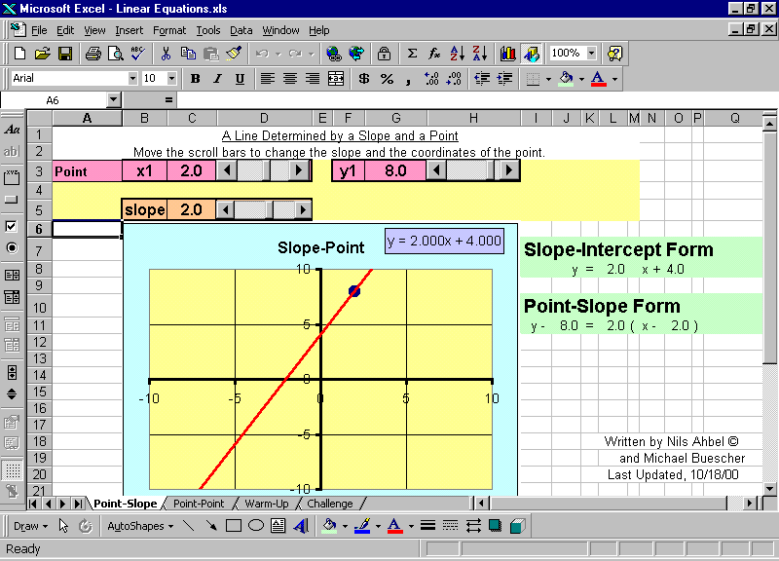
Discuss with Change the slope. What changes in each equation? What stays the same?
your partner:

Change the point. What changes in each equation? What stays the same?

Switch roles and move to the point-point page. Verify that all three equations are equivalent by changing both point-slope equations into slope-intercept form. Now change the points; write the two point-slope equations here, and simplify them both into slope-intercept form.

Warm-Up
Click on the “Warm-Up” tab on the bottom of the spreadsheet to change pages in the workbook. On this page, you are given two points and need to find the slope.

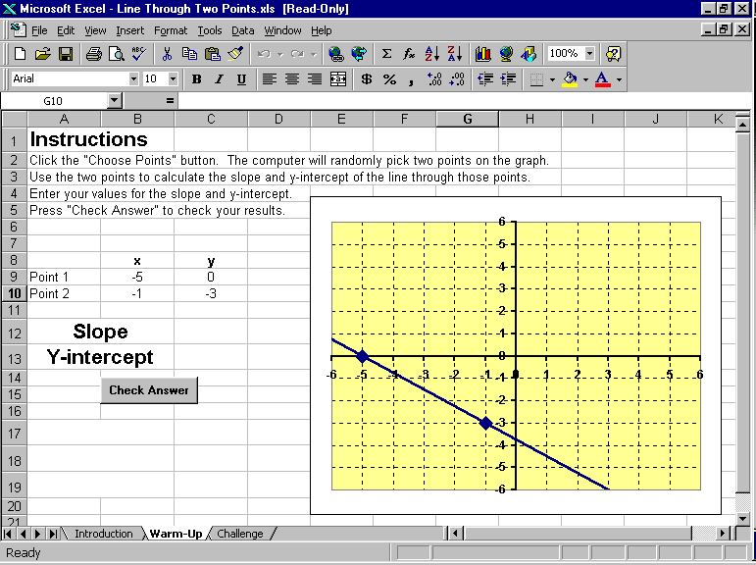
- Press the “Choose Points” button and the computer will randomly select two points.
- Determine the slope and y-intercept of the line that contains those two points. Enter the values you calculate into the “Slope” and “Y-intercept” cells. You may need some scratch paper to do the work. Hint: on this warm-up page, the slopes and y-intercepts are all FAIRLY nice numbers!
- A tip: You have to press [ENTER] after typing a number.
- After you have entered the slope and y-intercept, press the “Check Answer” button. You will find out if you were right or wrong!
Switch roles and do it again. Record your results!
Point 1: _________ Point 2: _________
Point-Slope Form: ____________________
Slope-Intercept Form: ________________
Point 1: _________ Point 2: _________
Point-Slope Form: ____________________
Slope-Intercept Form: ________________

The Challenge
Move to the Challenge page! This page works exactly the same way as the Warm-Up page did. The difference is that the numbers are not always so nice. Try your hand at some of these more challenging ones!
- Tip: For messy numbers, you need to enter either a fraction or a decimal rounded correctly to the nearest thousandth.
- Tip: When calculating the y-intercept, use the exact slope or at least 4 decimal places in your calculations.
Point 1: _________ Point 2: _________
Point-Slope Form: ____________________
Slope-Intercept Form: ________________
Point 1: _________ Point 2: _________
Point-Slope Form: ____________________
Slope-Intercept Form: ________________
When you get one right, congratulate yourselves! Then switch roles and let the other person do the calculations. Record your results here.

